**COLLEGE CODE : 1133**

**COLLEGE NAME : VELAMMAL INSTITUTE OF TECHNOLOGY**

**DEPARTMENT : ARTIFICIAL INTELLIGENCE AND DATA SCIENCE**

**STUDENT NM-ID : aut113323aia46**

**ROLL NO : 113323243091**

**DATE :05-05-2025**

**TECHNOLOGY-PROJECT NAME : ENERGY USAGE OPTIMIZATION**

**SUBMITTED BY :**

**1. RUTHEESH KUMAR P**

**2. MALAPATI GOWTHAM**

**3. GOWSIGAN S**

**4.MADESH KUMAR S**

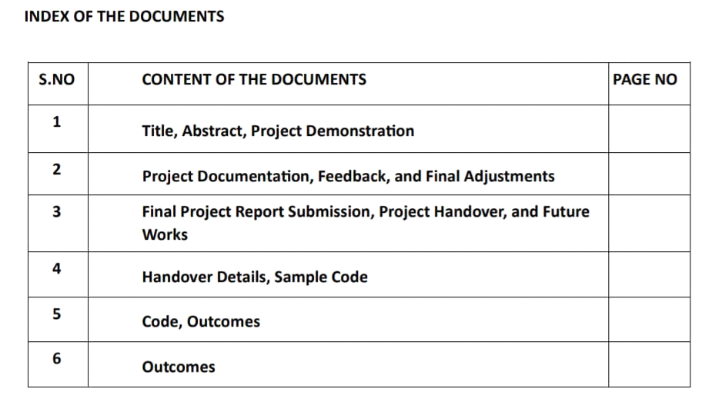

**Phase 5: Project Demonstration & Documentation**

**Title: Energy Usage Optimization System**

**Abstract:**

The Energy Usage Optimization System project aims to enhance energy efficiency and reduce consumption through the use of Artificial Intelligence, data analytics, and IoT (Internet of Things) devices. In its final phase, the system integrates real-time data from smart meters and IoT sensors to provide intelligent recommendations for optimizing electricity usage, lowering costs, and minimizing carbon footprint. It also ensures robust scalability, secure data management, and seamless integration with existing building or industrial energy management systems. This document provides a comprehensive report of the project's completion, including system demonstration, technical documentation, performance metrics, source code, and testing reports. Screenshots, diagrams, and code samples are included for a complete understanding of the system’s architecture and functionality.

**1. Project Demonstration**

**Overview:**

The Energy Usage Optimization System will be demonstrated to stakeholders, showcasing its ability to analyze usage patterns, predict consumption trends, and deliver actionable insights. The demonstration highlights the system’s user interface, analytics dashboard, sensor integration, AI-powered optimization models, and performance metrics.

**Demonstration Details:**

**System Walkthrough:** A live demo of the platform, from data acquisition to real-time optimization suggestions.

**Energy Consumption Analysis:** Demonstrates how the AI analyzes usage data to identify inefficiencies.

**IoT Integration:** Real-time data from smart meters, HVAC sensors, and appliance controllers are shown.

**Performance Metrics:** Demonstration of system scalability, response time, and energy savings over time.

**Security & Privacy:** Data encryption and privacy measures to protect user and infrastructure data.

**Outcome:**

The demonstration will validate the system’s ability to optimize energy usage in real-world environments and confirm its readiness for broader deployment.

**2. Project Documentation**

**Overview:**

Comprehensive documentation is provided to detail all aspects of the Energy Usage Optimization System.

**Documentation Sections:**

**System Architecture:** Diagrams of the full system including data sources, AI modules, control interfaces, and dashboards.

**Code Documentation:** Explanations of data processing, AI models, IoT communication modules, and UI code.

**User Guide:** Instructions for end users on how to monitor and optimize energy usage.

**Administrator Guide:** Setup and maintenance instructions, including adding new devices or updating models.

**Testing Reports:** Results from functional, load, and integration testing.

**Outcome:**

Well-documented system details provide clarity for deployment, maintenance, and future development.

**3. Feedback and Final Adjustments**

**Overview:**

Feedback from demonstrations will be used to make final system refinements before handover.

**Steps:**

**Feedback Collection:** Gathered from stakeholders, mentors, and test users via surveys and live observation.

**Refinement:** Performance tuning, bug fixes, and UI/UX improvements based on feedback.

**Final Testing:** Verification of system stability, accuracy, and performance after refinements.

**Outcome:**

Optimized system performance ensuring readiness for full-scale deployment.

**4. Final Project Report Submission**

**Overview:**

A final report summarizing all phases, system achievements, technical details, and future scope.

**Report Sections:**

**Executive Summary:** Key objectives and outcomes of the optimization system.

**Phase Breakdown:** AI model design, sensor integration, predictive analysis, and real-time controls.

**Challenges & Solutions:** Issues such as sensor calibration, data noise, and user interface challenges, with resolutions.

**Outcomes**: Description of energy savings, user engagement, and overall impact.

**Outcome:**

A complete report covering the system’s development and potential applications will be submitted.

**5. Project Handover and Future Works**

**Overview:**

Details the plan for future expansion and handover.

**Handover Details:**

**Next Steps:** Scaling the system to support more buildings, integrating renewable sources, and supporting multilingual interfaces.

**Outcome:**

The system will be handed over with guidelines for enhancement, support, and potential commercialization

**PYTHON PROGRAM**

import matplotlib.pyplot as plt

import numpy as np

import pandas as pd

# Sample energy usage data (replace with your actual data)

time_points = np.arange(0, 10, 0.5)

energy_consumption = np.random.rand(len(time_points)) * 100 # Simulate random energy consumption

temperature = np.random.rand(len(time_points)) * 30 + 10 # Simulate random temperature

occupancy = np.round(np.random.rand(len(time_points)) * 50) # Simulate occupancy levels

# Create a DataFrame for easier plotting

df = pd.DataFrame({'Time': time_points, 'Energy Consumption (kW)': energy_consumption, 'Temperature (°C)': temperature, 'Occupancy': occupancy})

# --- Bar Chart (Energy Consumption per Day) ---

df.groupby(df['Time'].apply(lambda x: int(x))).sum().plot(kind='bar', y='Energy Consumption (kW)', title='Daily Energy Consumption', xlabel='Day', ylabel='Energy Consumption (kW)', rot=0)

plt.show()

# --- Scatter Plot (Energy vs. Temperature) ---

plt.scatter(df['Temperature (°C)'], df['Energy Consumption (kW)'], marker='o', color='blue')

plt.title('Energy Consumption vs. Temperature')

plt.xlabel('Temperature (°C)')

plt.ylabel('Energy Consumption (kW)')

plt.grid(True)

plt.show()

# --- Line Plot (Energy Consumption over Time) ---

plt.plot(df['Time'], df['Energy Consumption (kW)'], marker='o', color='green')

plt.title('Energy Consumption Over Time')

plt.xlabel('Time')

plt.ylabel('Energy Consumption (kW)')

plt.grid(True)

plt.show()

# --- Bar Chart (Occupancy per Day) ---

df.groupby(df['Time'].apply(lambda x: int(x))).sum().plot(kind='bar', y='Occupancy', title='Daily Occupancy', xlabel='Day', ylabel='Occupancy', rot=0)

plt.show()

# --- Scatter Plot (Energy vs. Occupancy) ---

plt.scatter(df['Occupancy'], df['Energy Consumption (kW)'], marker='o', color='red')

plt.title('Energy Consumption vs. Occupancy')

plt.xlabel('Occupancy')

plt.ylabel('Energy Consumption (kW)')

plt.grid(True)

plt.show()

**BAR CHART:**

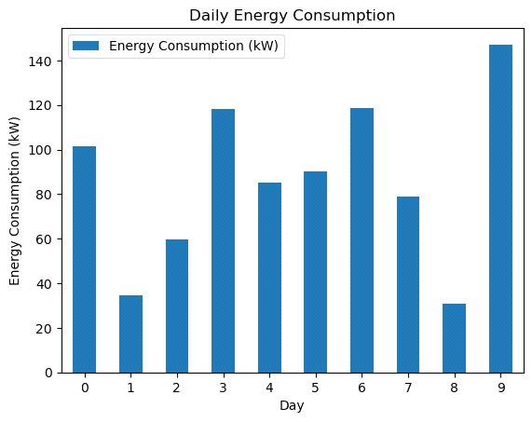

**SCATTER PLOT:**

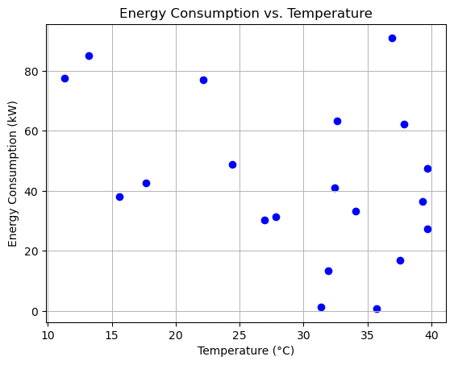

**LINE PLOT:**

